COMPONENT DIAGRAM

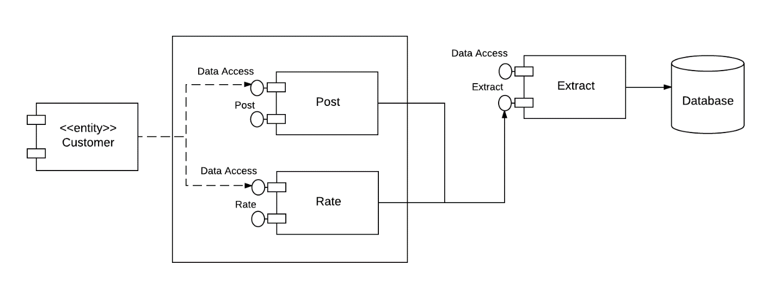

CONTINUITY FROM THE DATABASE

